

CENG 407
Innovative System Design and Development I
2025-2026 Spring

MULTI-LABEL CHEST X-RAY DISEASE CLASSIFICATION AND EXPLAINABILITY WITH DEEP LEARNING

METHODOLOGY

YAREN AKDOĞAN 202111046
SEZİN KÖROĞLU 202211046
İBRAHİM TAŞPINAR 202111072
CEVDET ALP ÖZGÜN 202211406
İPEK BAŞ 202211013
SALİH BARKIN AKKAYA 202211004
Abstract
This methodology presents an end-to-end system for multi-label thoracic disease classification from chest X-ray images, coupled with explainability and deployable software integration. The study uses the NIH ChestX-ray14 dataset and addresses key data challenges, including multi-label co-occurrence and severe class imbalance via a weighted learning strategy. To improve standardization and model robustness, images are filtered to Posterior–Anterior (PA) views and processed under multiple preprocessing pipelines (contrast/intensity enhancement, noise reduction, bone suppression, and frequency-domain filtering). All images are then standardized to a 224×224, three-channel format to support transfer learning with common pretrained backbones. The core model employs a DenseNet-121 backbone augmented with Convolutional Block Attention Modules (CBAM) inserted after each dense block to strengthen sensitivity to subtle radiographic patterns while maintaining computational practicality. For interpretability, Grad-CAM is integrated to generate class-specific heatmaps highlighting image regions that drive predictions. The system is operationalized through a RESTful backend that orchestrates preprocessing, inference, and explainability, and persists traceable outputs (predictions, metadata, model versions, and explanation artifacts) in a MongoDB-based schema with external file storage for large media. A Flutter frontend consumes the API to deliver user-friendly upload, results visualization, and history retrieval.

TABLE OF CONTENTS
- Dataset & Preprocessing Methodology .........................................................1
1.1. NIH ChestX-ray14 ..................................................................................1
1.2. Dataset Filtering (PA view only) .............................................................1
1.3. Preprocessing Pipelines ...........................................................................2 1.3.1. Preprocessing Methods That Have Been Implemented……...2 1.3.2. Preprocessing Methods That Will Be Implemented…….…...2 1.4. Standardization for the Backend …..........................................................3
- Model Architecture And Training ..................................................................4
2.1. DenseNet-121 Backbone ......................................................................... 4
2.2. Convolutional Block Attention Module (CBAM) ................................... 4
2.2.1. Channel Attention Module ........................................................... 5
2.2.2. Spatial Attention Module ............................................................. 5
2.2.3. Overall Proposed Architecture ..................................................... 5
2.3. Model Explainability Using Grad-CAM ................................................ 6
- Backend & Database Methodology Implementation......................................7
3.1. Database Infrastructure with MongoDB Atlas.........................................7
- Frontend ........................................................................................................11
5.1. Frontend Interaction and User Interface Design ....................................11
5.2. User Flow and Application Structure .....................................................11
5.3. Result Visualization and Grad-CAM Integration ..................................12
5.4. API Communication and Data Handling ...............................................12
5.5. Error Handling and User Feedback .......................................................12
- References ................................................................................................... 13

- Dataset & Preprocessing Methodology
  - NIH ChestX-ray14
Selection and the analysis of the dataset for this project, we selected the NIH ChestX-ray14 dataset, which is a standard for thoracic disease classification. We chose this dataset because it provides a sufficient amount of collection (112,120 chest X-ray images) which are labeled for 14 different conditions. During our analysis, we observed that the dataset has a multi-label structure. That means a patient could have multiple diseases at the same time.
We also identified a significant class imbalance issue. While common diseases like Infiltration had over 20,000 examples. Rare diseases like Hernia had very few samples. To prevent the model from ignoring these rare classes, we decided to create a weighted learning strategy for our training process. [1]

  - Dataset Filtering (PA view only)
Before starting the training process, we decided to filter the dataset based on the position of X-Ray views. The original dataset contains both Anterior-Posterior (AP) and Posterior-Anterior (PA) views. We chose to limit our dataset to PA views only, as they usually offer better standardization for deep learning models. We implemented a script that scanned the metadata and selected only the rows where the position of data was labeled as "PA". Based on this filtered list, we recreated the file directory and updated the training/testing split to ensure that no AP images were included in our final dataset.

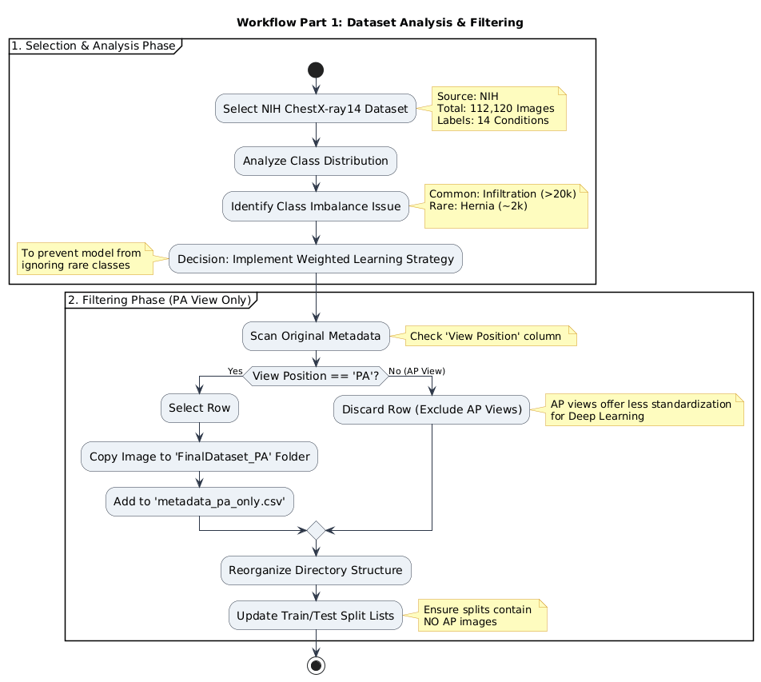
Figure-1: Dataset Analysis and Filtering Workflow Diagram
  - Preprocessing Pipelines
Since unprocessed X-ray images generally contain noise or varying lighting conditions, we designed four different preprocessing scenarios to improve the model's performance.
    - Preprocessing Methods That Have Been Implemented

These are the processing methods we have already implemented to see their effects on the results of our model training and to see whether or not they are suitable for the full application.

- Intensity Enhancement: In the first scenario, we focused on improving contrast. We applied Gamma Correction and Contrast Limited Adaptive Histogram Equalization (CLAHE) to make the details of lungs more visible. We also added an unsharp mask to make clear the edges [3],[5]. This method ultimately proved slightly less effective than simply using the images as they were found in the dataset and was discarded.

    - Preprocessing Methods That Will Be Implemented

These are the processing methods we are planning to implement after reaching a sufficient stage of development, where we can focus on minor improvements. We have applied these methods on a smaller scale to a limited number of images; however, we have not retrained the model or processed the full dataset using them.

  - Noise Reduction: In the second scenario, we decided to reduce noise. We used a median filter to make the image smoother while preserving edges. Also, by CLAHE and a sharpening kernel, we highlighted the desired structures [3],[4].

  - Bone Suppression: We experimented with a bone suppression technique to prevent the ribs from hiding lung abnormalities. We achieved this by subtracting a blurred version of the image from the original. That caused reducing the brightness of the bone structures and made the soft tissue clearer [3].

  - Frequency Domain Filtering: Finally, we tested a method combining CLAHE with a Butterworth band-pass filter. This allowed us to emphasize specific structural details in the frequency domain while removing high-frequency noise [2],[3].

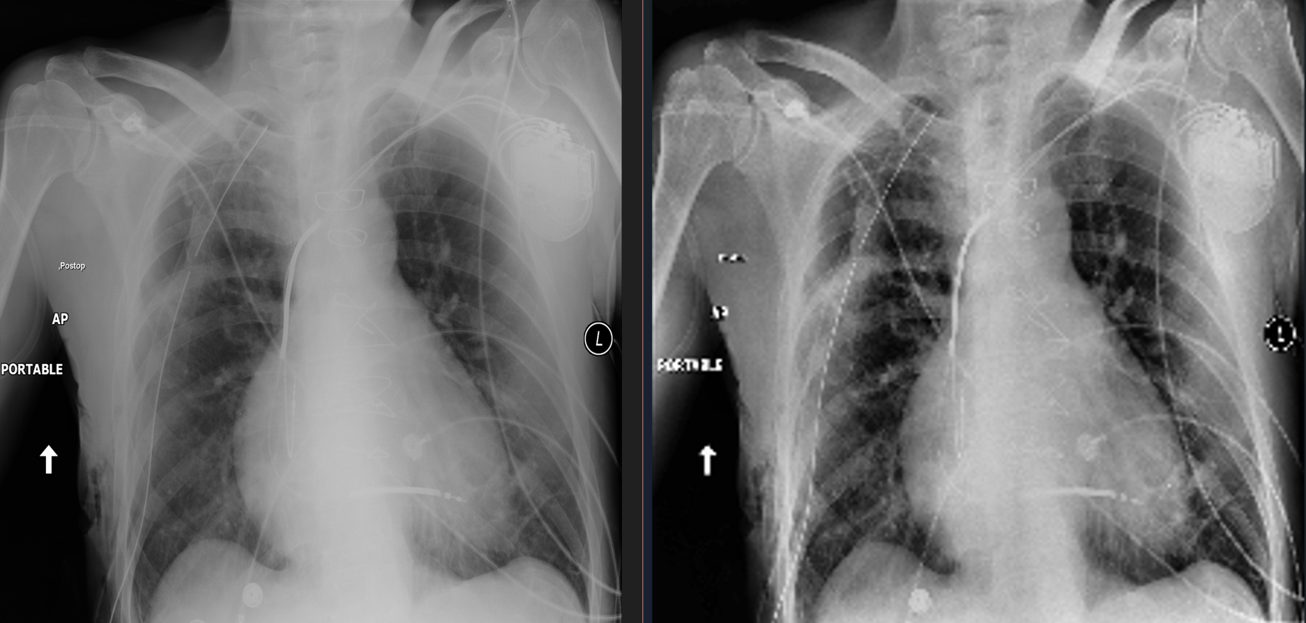
Figure-2: Intensity Enhancement

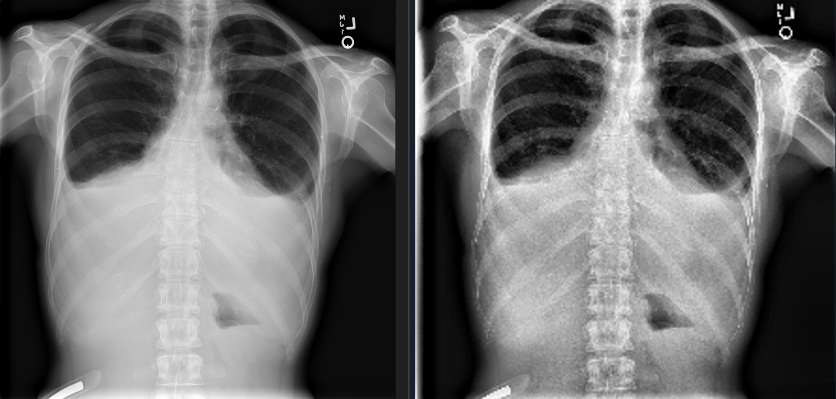
Figure-3: Noise Reduction
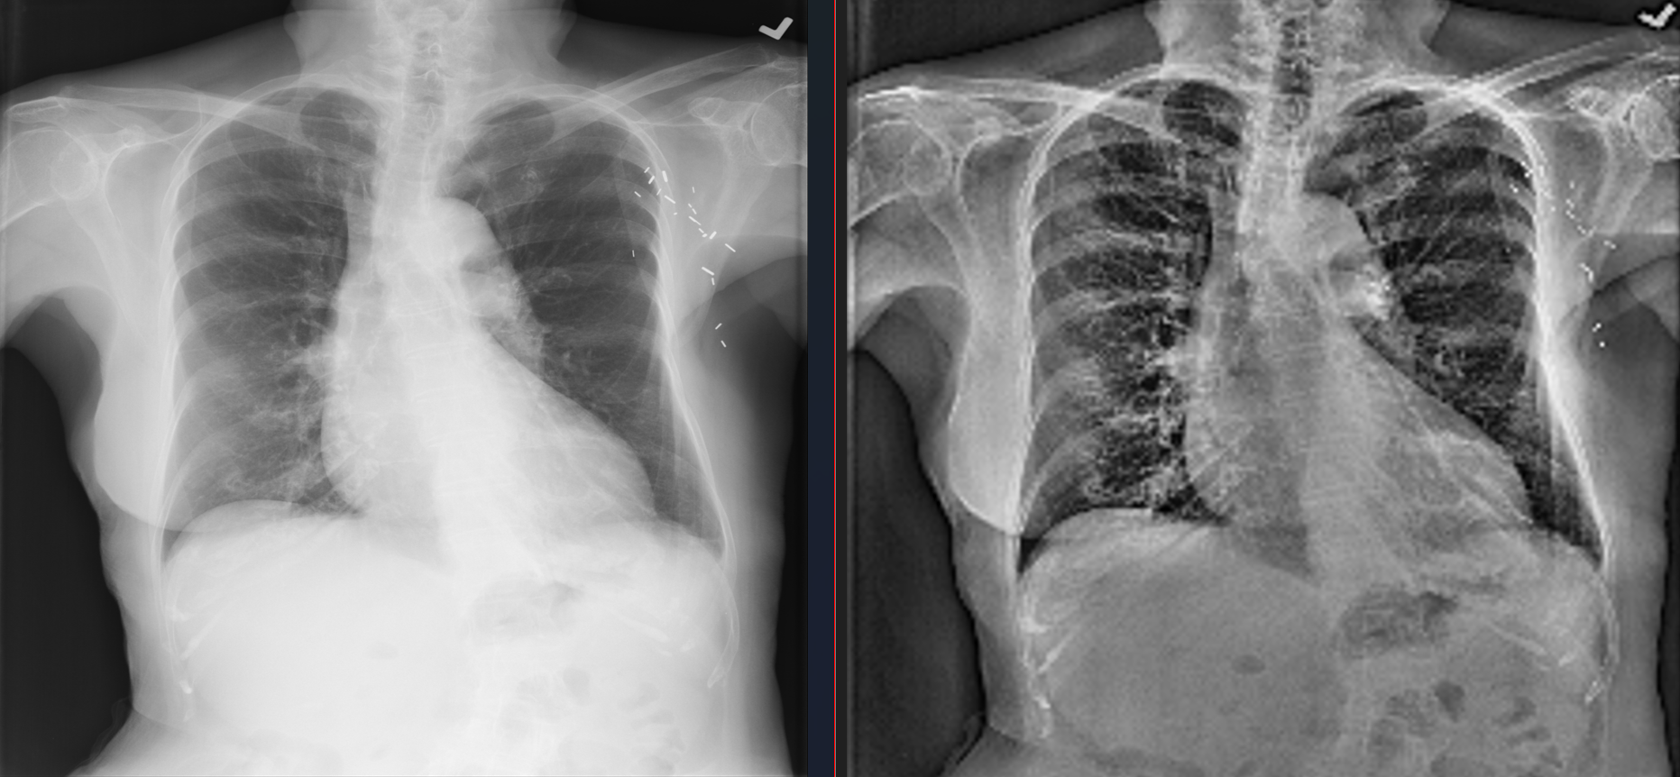

Figure-4: Bone Suppression

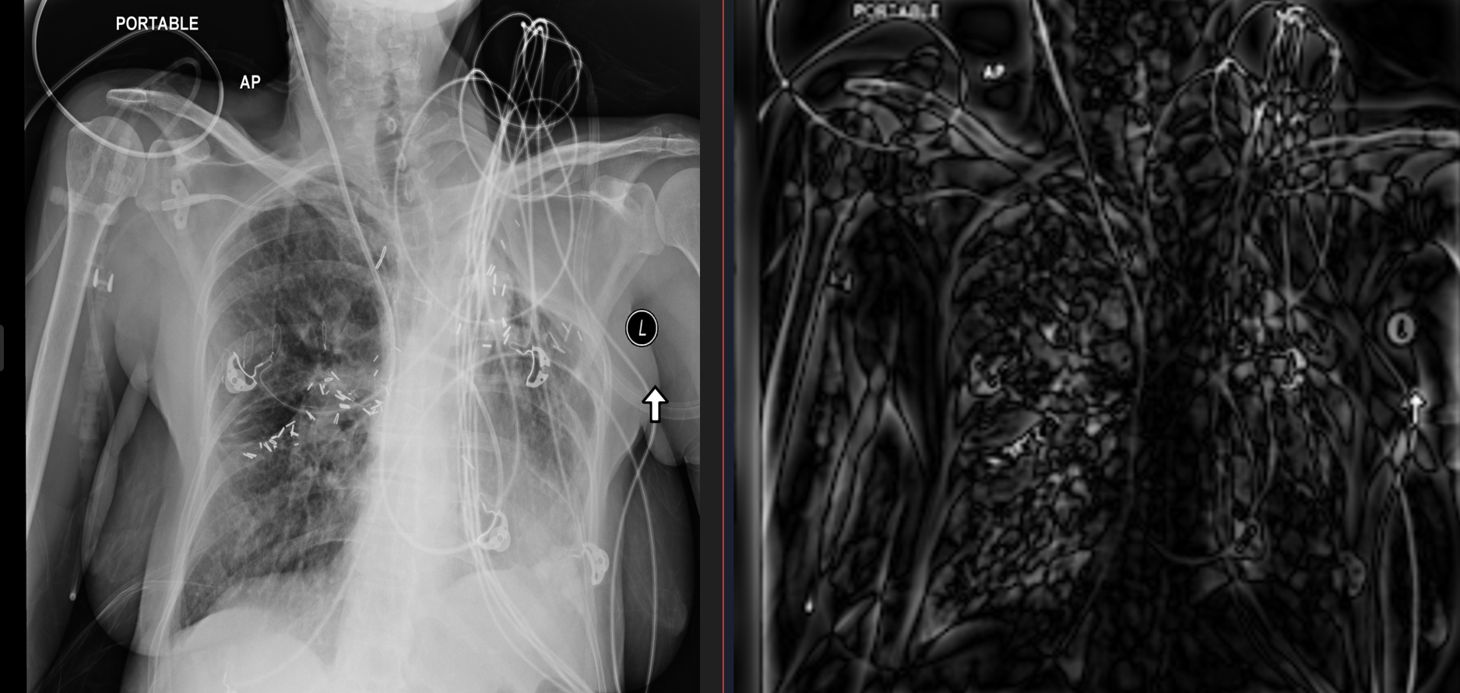
Figure-5: Frequency Domain Filtering

  - Standardization for the Backend

Independent of the chosen preprocessing strategy, we decided to put our processed dataset in a standard format. This method ensured the compatibility with our backend system. For every image in our dataset, we resized the resolution to 224x224 pixels. Even though the X-rays images in our dataset are originally in grayscale format we converted them into a 3-channel RGB format by repeating the grayscale channel three times. This decision was made to give us the opportunity to use pre-trained deep learning architectures (DenseNet, ResNet, etc.) that expect 3-channel input by default.

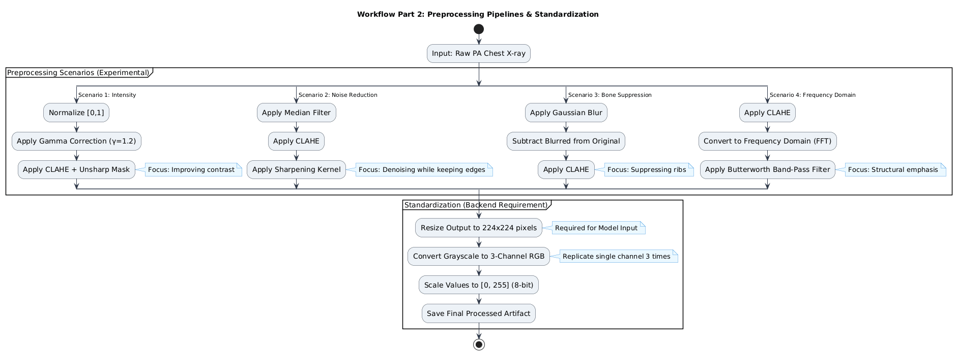
Figure-6: Preprocessing Pipelines and Workflow Diagram
- Model Architecture And Training
  - DenseNet-121 Backbone
We have chosen DenseNet as the backbone of our model due to its proven success in medical image classification tasks. The dense connectivity technique used in DenseNet allows the outputs of previous layers to be utilized in all future layers within a dense block in the model, which mitigates the possible vanishing gradient issues we may encounter [6]. The pretrained ImageNet weights of DenseNet also allow for faster convergence and stable training. The segmented structure of DenseNet allows for the insertion of different modules between its dense blocks, which is perfect for our project. The dense blocks are made up of bottleneck layers with dense connectivity and make up a large part of the model. Bottleneck layers start with batch normalization and ReLU followed by a 1x1 convolutional layer, after which another batch normalization and ReLU, and end with one final 3x3 convolutional layer [6].
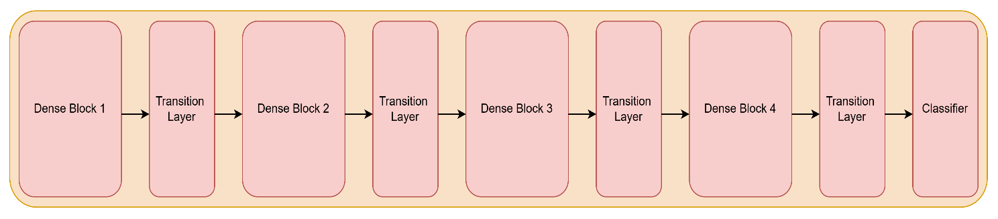
Figure-7: High Level Architecture of DenseNet-121

  - Convolutional Block Attention Module (CBAM)
CBAM is an attention module comprised of two smaller components called channel attention module and spatial attention module respectively [7]. Neither component affects the input or output sizes of the layers before and after them thus allowing for easy insertion into our model.
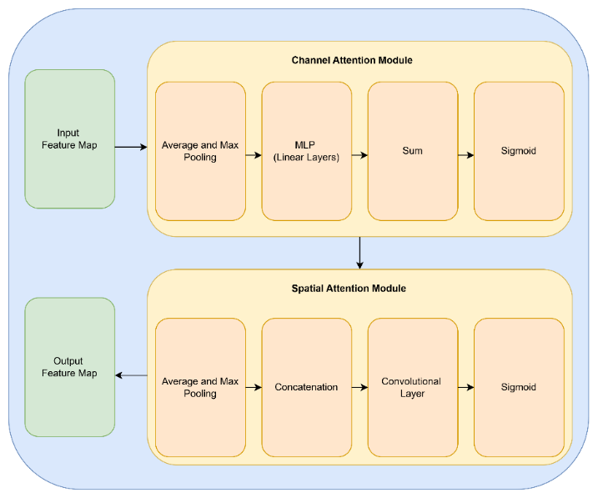
Figure-8: High Level Architecture of CBAM

    - Channel Attention Module
The channel attention module decides what features are important for a given task. The module applies average and max pooling to model the current features and passes them to an MLP. The sigmoid of the sum of the resulting features is multiplied with the current model features to update the feature map of the model [7].
    - Spatial Attention Module
The spatial attention module focuses on where important regions are on the feature maps. Similarly to the channel attention module, it applies average and max pooling across channels to generate maps that highlight where important features are. These feature maps are concatenated to make a feature map with two channels which is passed through a convolutional layer without changing its size while reducing the channel count back down to one. The sigmoid of the resulting map is multiplied with the current feature map to highlight important spatial regions [7].
    - Overall Proposed Architecture
Our model adds a CBAM module after each dense block without changing the feature map size to avoid compatibility issues with subsequent dense blocks. By adding this module after each dense block, we aim to create a model that is more capable of detecting the small differences present in X-ray images without causing an excessive processing load on devices. Due to the precise nature of diagnosing thoracic diseases from X-ray images, we aim to optimize our model’s confidence and interpretability. We are planning on using F1 and F1 macro as our metrics during development to evaluate the performance of our model.
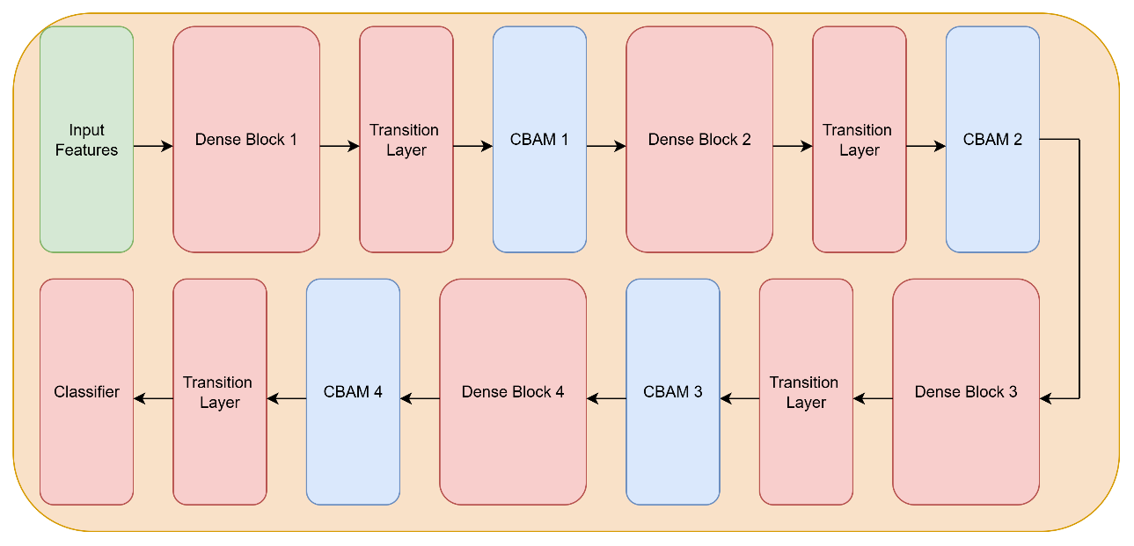
Figure-9: High Level Architecture of Our Model

  - Model Explainability Using Grad-CAM
Grad-CAM will be integrated into the model outputs to improve model interpretability. Grad-CAM will be used to visualize the areas that are relevant to the predictions our model makes by generating individual heatmaps over the original X-ray image for each possible disease class [8]. Through this technique, we aim to increase the trust of users by giving them the ability to see why the model came to a decision.
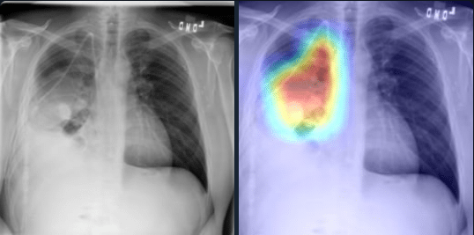
Figure-10: Original X-ray Image and The Grad-CAM Heatmap of The Same Image

  - Model Training and Loss Functions
The model training was designed for the multi-label nature of the dataset and to address the class imbalance across disease categories. Since each chest X-ray image may contain multiple pathologies simultaneously, the training methods and loss functions were selected with multi-label classification in mind.
    - Binary Cross Entropy with Logits Loss (BCEWithLogitLoss)

We used Binary Cross Entropy with Logits Loss as our initial baseline for our model. This loss function combines a sigmoid activation with binary cross entropy in a single equation and is widely used for multi-label classification tasks.

However, BCEWithLogitsLoss does not provide a way to get around the sample imbalance issue of our dataset. For the NIH ChestX-ray14 dataset, this can lead to the model performing much worse on rare disease classes.

    - Asymmetric Loss (ASL)

To overcome the class imbalance limitations of our baseline, we implemented Asymmetric Loss (ASL) as an alternative. ASL is specifically designed for imbalanced multi-label classification and can internally reduce the dominance of prevalent classes and allow for the model to learn less common ones.

The loss function applies asymmetric focusing to positive and negative samples, allowing the model to assign less importance to negative examples while emphasizing harder and more informative samples.

By emphasizing difficult examples and decreasing the weight of weighting common negatives, ASL improves the model’s ability to detect subtle and rare thoracic diseases.

    - Training Configuration And Hyperparameters
Transfer learning was used by initializing the DenseNet-121 backbone with pretrained ImageNet weights. The model was trained using the Adam optimizer with a learning rate of 1e-4.
Input image resolution was only lowered from 1024x1024 to 512×512 to preserve details that are important for detecting thoracic diseases. A batch size of 8 was used due to the large size of our dataset and the high resolution of our images.
Model performance was evaluated using F1 score and macro F1 score metrics, which provide a more accurate assessment in multi-label classification tasks.

- Backend & Database Methodology Implementation
In this phase of the project, the architectural decisions made during CENG 407 have been fully implemented to establish a functional and scalable backend infrastructure. The system has been operationalized to ensure high availability and seamless data management for medical imaging workflows.

3.1. Database Infrastructure with MongoDB Atlas
For robust data management, a cloud-based cluster has been deployed using MongoDB Atlas, aligning with our strategy for handling flexible schema requirements.
- Database Structure: A dedicated database named "Ceng408" has been initialized within the cluster to manage project-specific data.
- Collection Organization: To ensure traceability, data is organized into three primary collections:
  - Doctors: Stores authentication details and profile information, including fields like full_name, email, and role (e.g., "doctor").
  - Patients: Manages patient demographics and links to their diagnostic history.
  - Analyses: Persists inference results, multi-label probability scores, and references to Grad-CAM heatmap paths.
- Access Control: To maintain system integrity, a strict administrative policy is enforced where only the two team members responsible for the backend have "Admin" privileges on the cluster.
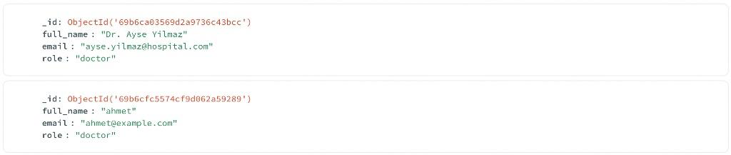
Figure -11: An example of a sample data.

Explainability Workflow (Grad-CAM)
The explainability component using Grad-CAM has been integrated directly into the backend infrastructure as a core capability. This integration allows clinicians to visualize the specific regions of the chest X-ray that contribute most to the model’s diagnostic predictions.
- Operational Logic: Grad-CAM is treated as a separate, on-demand action within the backend to manage the additional computational load effectively.
- Data Management: Once a heatmap is generated, it is saved as an image file on the server's storage layer, and its corresponding metadata and URL are persisted in the Analyses collection in MongoDB.
- Traceability: This workflow enables the system to store a permanent record of how a specific model version produced a particular visual explanation, supporting later clinical review and auditability.
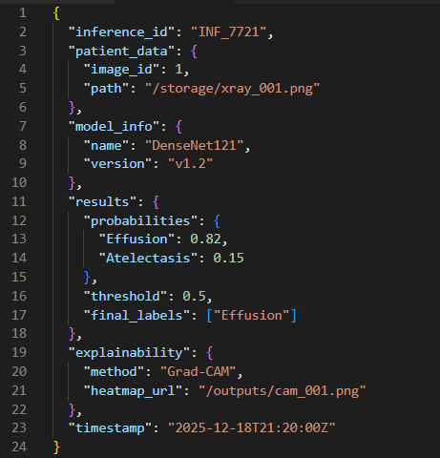
Figure -12: An example of a JSON document from our database. It shows how we store the model's probability scores and the file paths for the Grad-CAM outputs in one place.

- Frontend
  - Frontend Interaction and User Interface Design
This section of our report explains how the user will interact with our system through the Flutter-based frontend and how the results produced by the deep learning model will be presented to the user in a clear and understandable way.
The Flutter application will act as the client side of the system and will be responsible only for user interaction and visualization. All heavy operations such as image preprocessing, model inference, and Grad-CAM generation will be handled on the backend side [13],[14].
  - User Flow and Application Structure
We plan to design the Flutter application with a simple and intuitive user flow. First, the user will be able to select a chest X-ray image from their device. After the image is selected, it will be displayed on the screen so that the user can confirm the correct image before analysis.
Once the user starts the analysis, the selected image will be sent to the backend through the defined API endpoint. During this process, a loading indicator will be shown to inform the user that the analysis is in progress. After the backend completes the inference, the results will be sent back to the Flutter application and displayed to the user [15].
  - Result Visualization and Grad-CAM Integration
The results page of the application will display the predicted diseases together with their probability values. These values will help the user understand how confident the model is about each prediction.
For model explainability, Grad-CAM heatmaps generated on the backend will be visualized in the Flutter interface.
  - API Communication and Data Handling
Image uploads will be handled using multipart requests, while prediction results and metadata will be transferred in JSON format. [16],[17].
On the client side, the received JSON responses will be parsed and mapped to internal data structures. This structure will allow the application to safely display disease probabilities, Grad-CAM image references, and possible error messages returned by the backend. [18].
  - Error Handling and User Feedback
User experience and system robustness are important aspects of the frontend design. For this reason, the Flutter application will handle different error scenarios and provide informative feedback to the user.
If no image is selected or an unsupported file is uploaded, the user will be warned before the request is sent. In case of network problems or server-side errors, meaningful messages will be displayed and the user will be allowed to retry the operation [17].

6. References
[1] National Institutes of Health, “NIH Chest X-rays Dataset,” Kaggle, [Online].
Available: https://www.kaggle.com/datasets/nih-chest-xrays/data.
Accessed: 19 Dec. 2025.
[2] A. Giełczyk, A. Marciniak, M. Tarczewska & Z. Lutowski, “Pre-processing
methods in chest X-ray image classification,” PLOS ONE, vol. 17, no. 4, e0265949, Apr.
2022.
Available: https://journals.plos.org/plosone/article?id=10.1371/journal.pone.0265949
Accessed: 19 Dec. 2025.
[3] IEEE Xplore, “Article (document no. 10955260),” [Online].
Available: https://ieeexplore.ieee.org/stamp/stamp.jsp?tp=&arnumber=10955260.
Accessed: 19 Dec. 2025.
[4] “Median Filter – an overview,” ScienceDirect Topics, Elsevier, [Online].
Available: https://www.sciencedirect.com/topics/engineering/median-filter.
Accessed: 19 Dec. 2025.
[5] N. F. Sahib and Z. A. Hashim, “Contrast Image Enhancement by Gamma
Correction,” Computer Engineering and Intelligent Systems, vol. 9, no. 7, 2018.
Available: https://scispace.com/pdf/contrast-image-enhancement-by-gamma-
correction-3upr34p2k1.pdf.
Accessed: 19 Dec. 2025.
[6] G. Huang, Z. Liu, L. van der Maaten, and K. Q. Weinberger, “Densely Connected Convolutional Networks,” Proceedings of the IEEE Conference on Computer Vision and Pattern Recognition (CVPR), 2017, [Online].
Available: https://arxiv.org/abs/1608.06993
Accessed: 20 Dec. 2025.
[7] S. Woo, J. Park, J.-Y. Lee, and I. S. Kweon, “CBAM: Convolutional Block Attention Module,” Proceedings of the European Conference on Computer Vision (ECCV), 2018, [Online].
Available: https://arxiv.org/abs/1807.06521
Accessed: 20 Dec. 2025.
[8] R. R. Selvaraju, M. Cogswell, A. Das, R. Vedantam, D. Parikh, and D. Batra, “Grad-CAM: Visual Explanations from Deep Networks via Gradient-Based Localization,” IEEE International Conference on Computer Vision (ICCV), 2017, [Online].
Available: https://arxiv.org/abs/1610.02391
Accessed: 19 Dec. 2025.
[9] X. Wang et al., “ChestX-ray8: Hospital-scale chest X-ray database and benchmarks on weakly-supervised classification and localization of common thorax diseases,” CVPR, 2017.
[10] I. E. Ihongbe et al., “Evaluating Explainable Artificial Intelligence (XAI) techniques in chest radiology imaging through a human-centered lens,” PLOS ONE, 2024.
[11] J. Irvin et al., “CheXpert: A Large Chest Radiograph Dataset with Uncertainty Labels and Expert Comparison,” AAAI, 2019.
[12] J. Han et al., “BO-CLAHE enhancing neonatal chest X-ray image quality for improved lesion classification,” Scientific Reports, 2025.
[13] Flutter Team. Flutter Documentation.
https://docs.flutter.dev
[14] Google Developers. Flutter Architectural Overview.
https://docs.flutter.dev/resources/architectural-overview
[15] ISO/IEC 25010:2011. Systems and software Quality Requirements and Evaluation (SQuaRE).
[16] ECMA International. (2017). The JSON Data Interchange Syntax (ECMA-404).
[17] Mozilla Developer Network (MDN). HTTP Overview and Status Codes.

